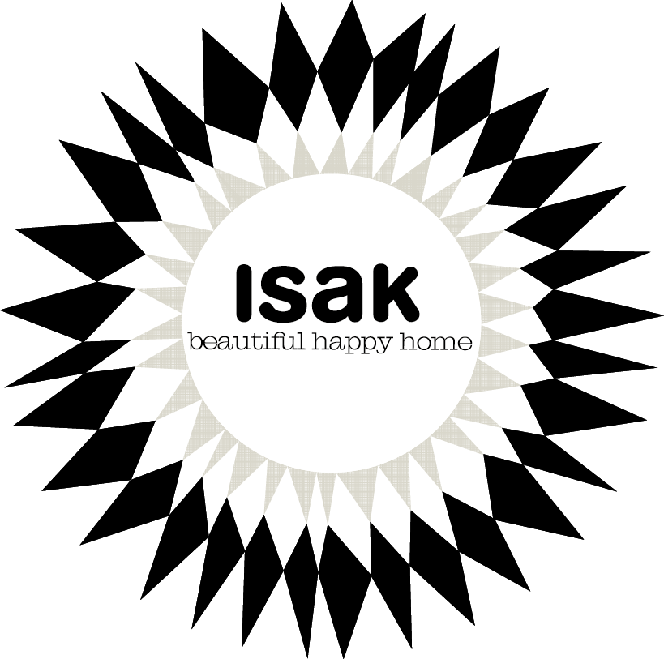

Midnattssol by Isak
Midnattssol (Swedish for Midnight Sun) is the new and beautifully nostalgic collection of eco-friendly Scandinavian home accessories and kitchenware from Isak. The range is inspired by Nordic heritage, the seasons and nature itself. Midnattssol celebrates the vast contrast between Scandinavian summers and winters, dark and light, through a signature monochromatic style. The collection, to be launched at Top Drawer September 2016, consists of hard-wearing kitchen essentials including enamel cooking pots and pans, ceramic jugs, serving bowls, mugs and plates, 100 per cent cotton blankets and tea towels and napkins, and hand turned wooden candlesticks, kitchen utensils and trays and placemats.
Isak was established by Swedish-born designer Sandra Isaksson with the simple aim of making life a little more beautiful. Sandra says, “I found inspiration for this collection in the dramatic landscapes of Iceland, the culture of my Swedish homeland, and in the nature of my new home in England. The range of products is a reflection of how I live with my family. We often cook on the beach or in the forest, we grow our own vegetables and we like to forage, pickle and preserve. Midnattssol is a collection of practical and user-friendly products for the dining table, whether you choose to eat inside or out.”
Since Isak was brought to life in 2006, the environment has been at the heart of its ethos. The company is committed to using the best materials available creating a quality and ethical final product; the wood used comes from sustainable sources, and recycled paper products and vegetable inks are also used. Isak prides itself on producing items with integrity, which will last for years and can be passed on to future generations.

