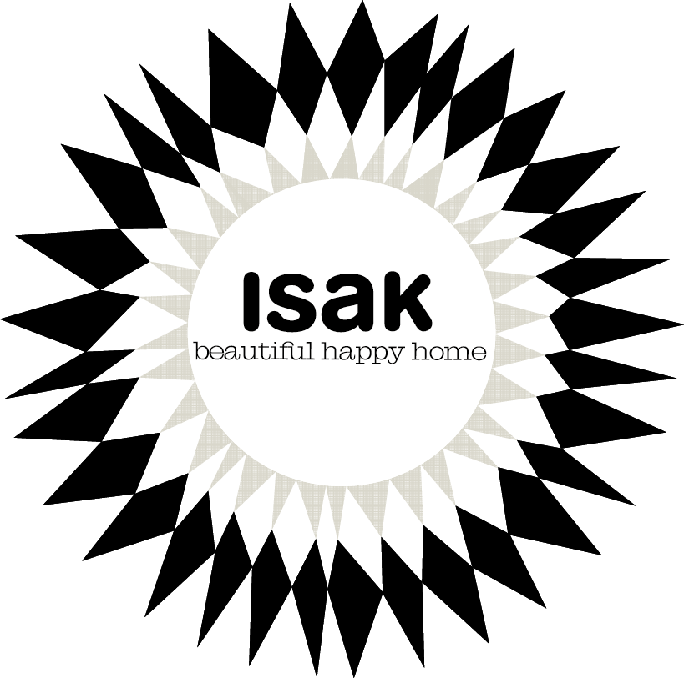

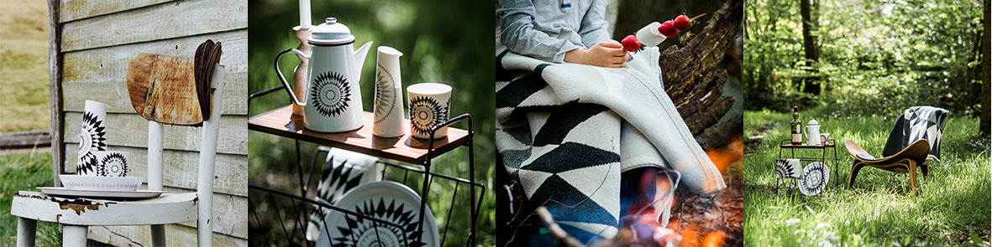

Midnattssol, the range

The sun has such meaning for people of the north; we always feel that we never have enough of it. There is a feeling of sadness and loss in autumn, watching every day become shorter and shorter. We eagerly turn our faces to the sun in the few hours of fleeting winter light and dream of long bright summer nights. We long for the first warming rays of spring, shining through the melting ice. When the light starts to come back and when summer finally arrives, we worship the sun. Midnattssol is a celebration of our Scandinavian heritage. Summer and winter, black and white, darkness and light. A beautiful happy place!

Enamel
Our ceramic enamel is dishwasher safe and oven safe up to 180 °C. Do not use enamel in microwaves. It is safe for use on gas, electric and induction hobs. Match cookware to the size of your heat source and select low to medium heat for best results. Just like any other ceramic, the outer porcelain layer can chip if dropped, revealing the steel beneath it. When this happens the steel below naturally oxidises and the enamelware remains safe to use. Enamelware is glass fused onto heavy-gauge steel. This makes it smooth, durable and chemically-resistant as well as great at holding brilliant, long-lasting colours. These products are hand-enameled and small imperfections can be expected.

To prevent cracking or warping, let the enamelware cool before contact with cold water. To remove stubborn food residue soak before cleaning.
Use a sponge or cloth with hot soapy water when cleaning. Never use abrasive scouring powders, pads or steel wools when cleaning as this may damage enamel coating. Use wooden, plastic or heat -resistant nylon tools. The maximum limit to fill the cookware should be about 60-70% of its capacity. Handles and knobs may get hot. Always use pot-grabs and place on heat-resistant surface. Do not pre-heat the cookware or place over heat when empty.

Ceramic
Dishwasher, microwave and oven safe.
Do not immerse a hot dish from the oven in cold water as this may cause the item to crack. To remove stubborn food residue soak before cleaning.
Use a sponge or cloth with hot soapy water when cleaning. Never use abrasive scouring powders, pads or steel wools when cleaning as this may damage enamel coating. Use wooden, plastic or heat -resistant nylon tools.

This ceramics range has been produced ethically and sustainably in Indonesia by our chosen manufacturer who supports the local community of its employees with a school, a nursery and a lunch cantina. By using the best materials available and a state-of-the-art facility we ensure that you get a sustainable product that will last for a very long time. Each piece is fired at a temperature of 1300ºC to create an incredibly strong and thin fine porcelain.

The decal is applied by hand using underglaze technology and fired three times.
Under-glaze means that the colours and patterns of the decal are permanently locked in to the glaze by the high temperature firing process. These processes result in a stronger longer-lasting tableware with virtually scratch
proof patterns.

Tea towels and napkins/ table cloths
50% cotton and 50% linen, made in Lithuania to OEKO-TEX® Standard 100.
Machine washable in 40 degrees.

Blanket
100% cotton, made in Lithuania, OEKO-TEX® Standard 100. Machine washable in 40 degrees.

Wooden utensils & Candleholders
Our steels are made in Norway and our wooden handles and candleholders are handmade from beech wood in East Sussex. The handles can be rubbed with olive oil to give them a little protection and water resistance for washing. Do not soak in water. Use a sponge or cloth with hot soapy water when cleaning.

Trays
Our birch wood trays are made from sustainable Scandinavian wood and have a melamine coating. They are machine washable.

Trivets/ place mats
Our trivets and placemats are made from sustainable HDF material, sourced from Scandinavian sustainable forestry. Do not soak in water, clean in lukewarm water with a soapy cloth, rinse and dry.

